Blinky Kit Instructions

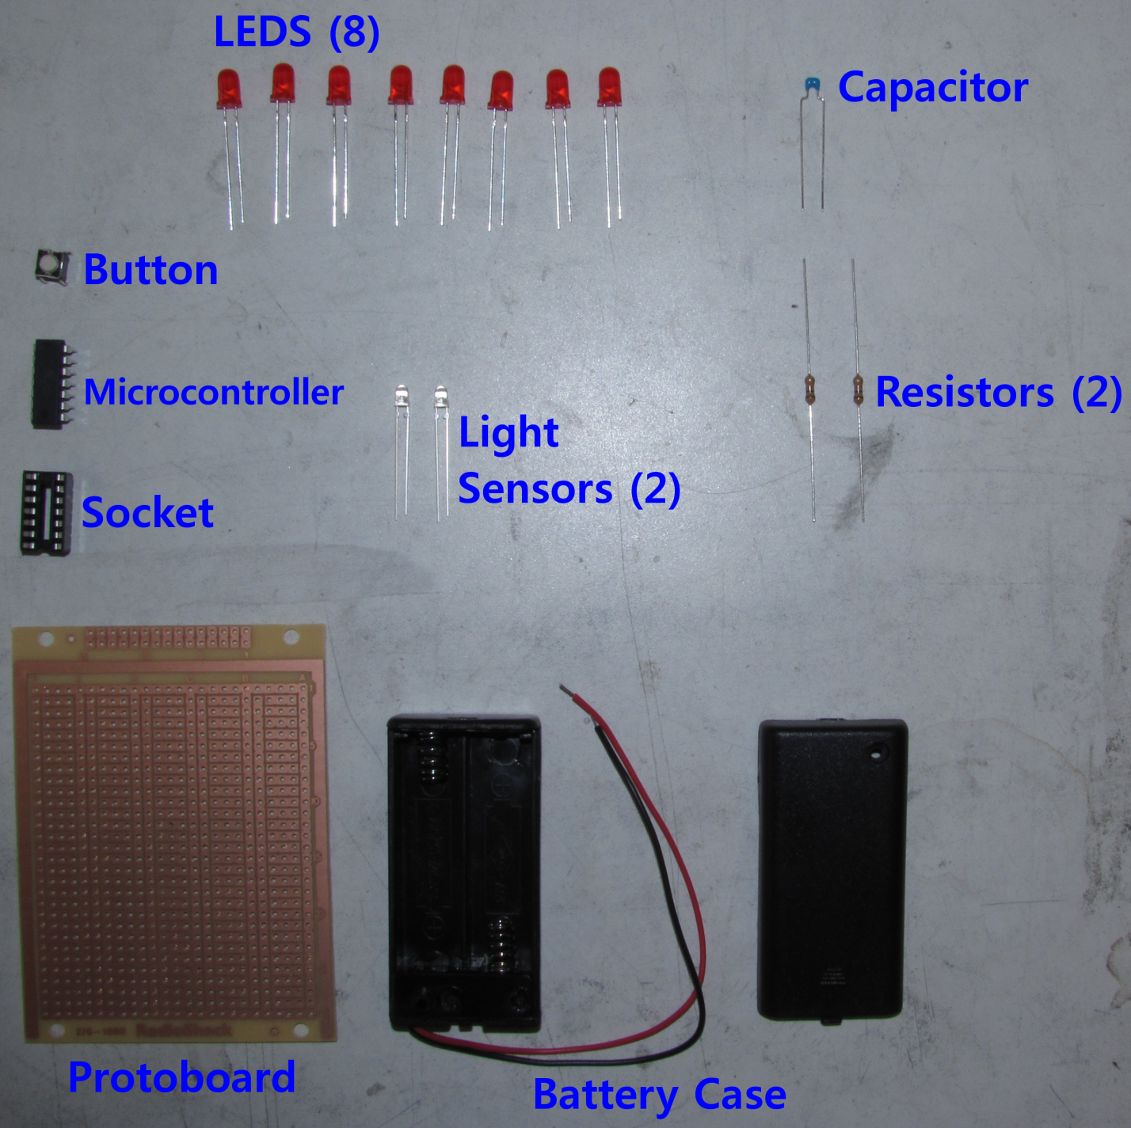

You should have everything pictured here. Your button, microcontroller and socket will be inside your battery case.

Tools:

|  |  |
| --- | --- |
|  |  |
|  |  |